**********************

**Assignment 6:-**

**********************

* Create a Header Page as shown Below

**Header.html**

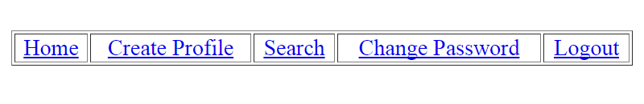

* Create a Footer Page as shown Below

**Footer.html**



* Include these Header & Footer in all the previous assignments
* In case of assignment 5, “Generate Login Page with Error Information” when credentials are in-valid and include Header & Footer for the proper response